Documentation – With attached screenshots for steps.

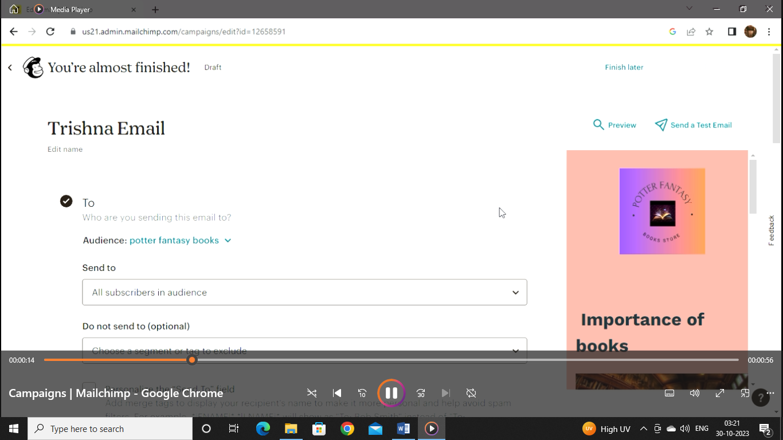

Step 1: Fill the To content (recipients)

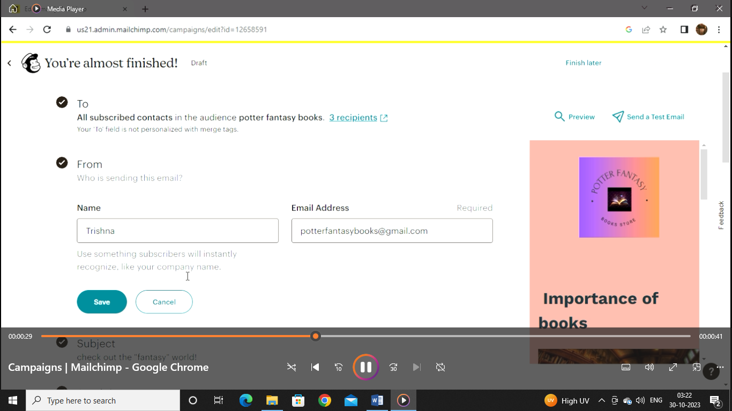

Step 2: Fill the From content

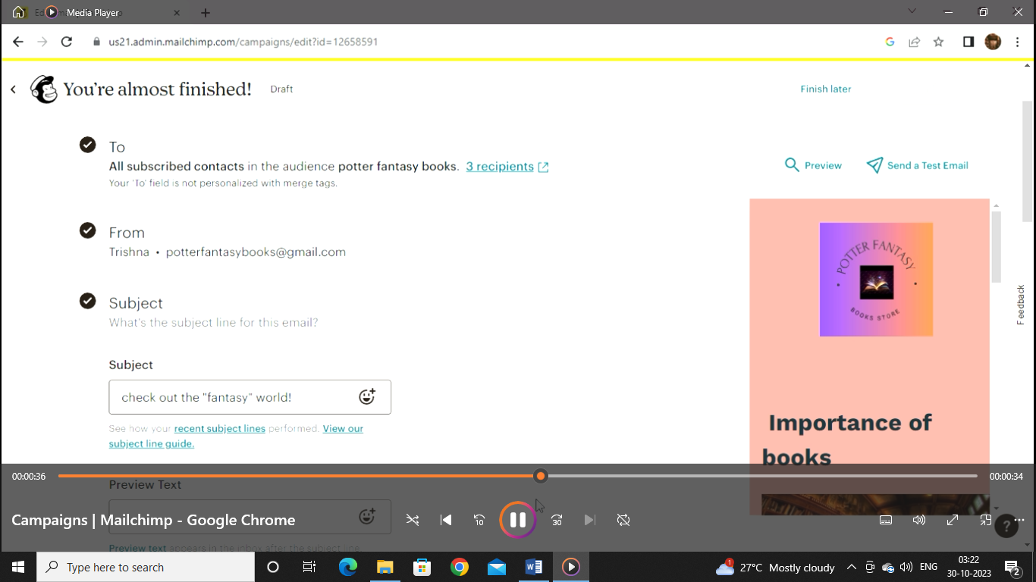

Step 3: Fill the subject content

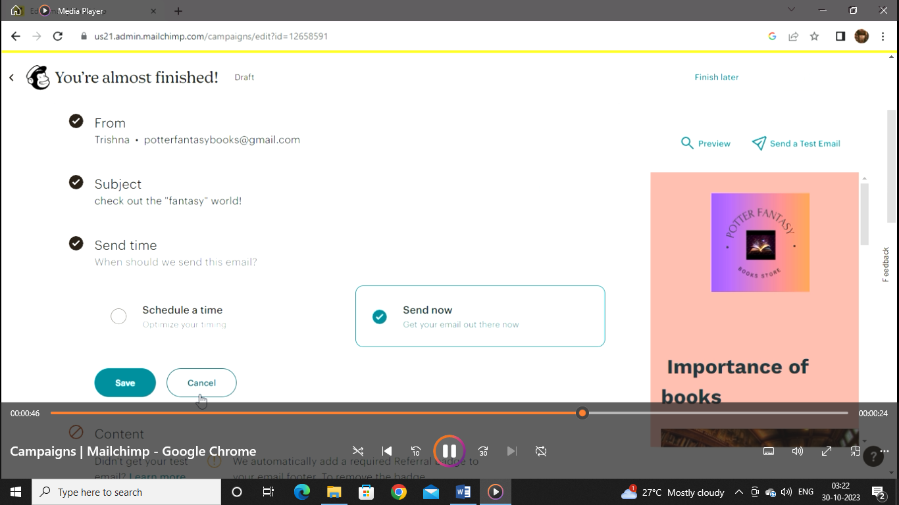

Step 4:Fill the sent time

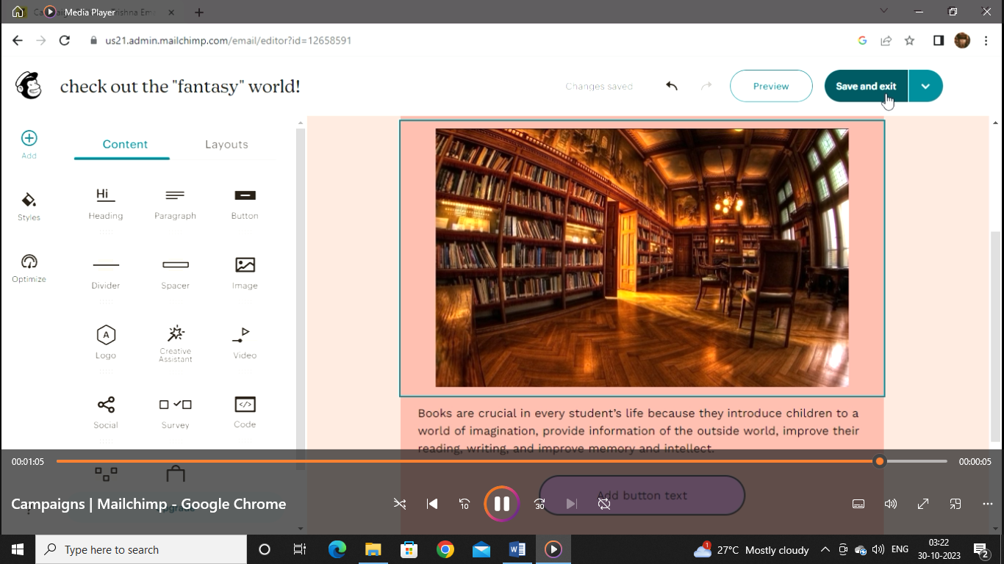

Step 5: Create the template

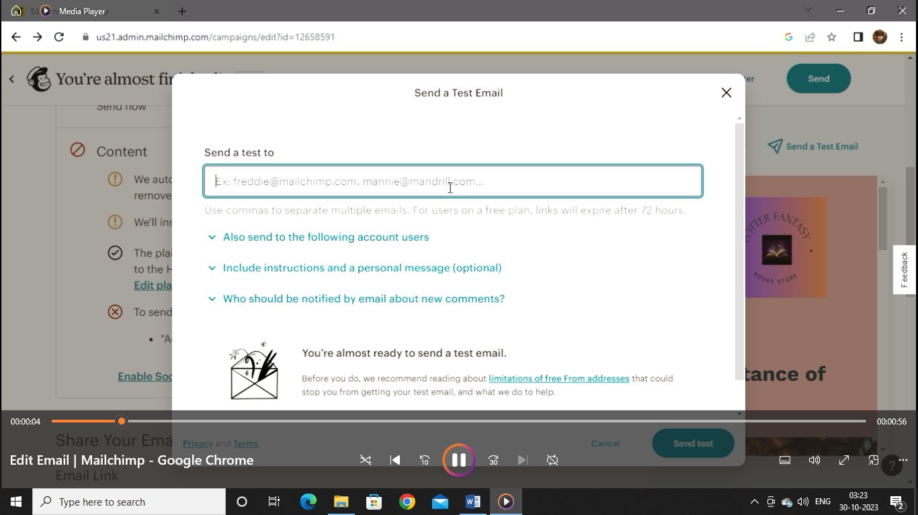

Step 6: Send the test email